Scholarship
Each year, Piamistry offer two scholarships to new students based on who can demonstrate an exceptional aptitude for the piano. Scholarships are means tested. They are decided by merit and income, and their value varies between a 25% and 90% reduction in tuition fees. Each scholarship is awarded for course of 3 months (up to 12 lessons) and then reviewed.

Fill out form below, print and bring to your scheduled lesson
-or-
Fill out form and email to ahmunmiles@gmail.com

Instructor Co-Instructor
Ms. Ahmun Miles Mrs. Dianne Miles
Cell: 205-746-0557 Cell: 205-527-1751
Email: Ahmunmiles@gmail.com Email: dmatt86038@aol.com

Ahmun Miles is a young, aspiring classical pianist in Birmingham, Alabama. Music has been Ahmun’s passion since a very young age as she continues to expand her repertoire. Her platform is to promote entrepreneurship in the youth as well as recognize other youth talent. She strives to introduce Classical music to children as well as teach children the fundamentals of music and the many techniques of piano playing. Ahmun is a former student of “Young Musical Geniuses of Birmingham”. While being a student of Young Musical Geniuses, she was in affiliation with the National Federated Music Club whereas, each year, she participates in piano auditions under the auspices of NFMC, as a result, Ahmun has received Gold Cups and numerous Superior Ratings of the Solo, Hymn and Theory Festival Events and was also entitled to Cash Awards. Ahmun currently attends the University of Alabama at Birmingham where she is pursuing her degree in Music.

Student Application

Student’s Full Name______________________________________________________________________
Home & Mobile Phone_____________________________________________________________________
Student’s Address_________________________________________________________________________
City_____________________________State___________________________Zip_________________________
Birthday______________________________________________Age__________________________________
Method Used______________________________________________________________________________
Other Instrument(s) ________________________________________________________________________
Mother’s Occupation_______________________________________________________________________
Father Occupation _________________________________________________________________________
Emergency Contact Information____________________________________________________________
Email________________________________________________________________________________________
Religious Preference________________________________________________________________________
Allergies ____________________________________________________________________________________
Permission to Take Pictures for website Yes?/No?_________________________________________
Signature_________________________________________________Date_____________________________

PIAMISTRY
T Shirts
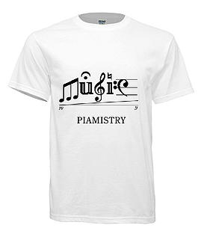
Music -T- Shirt Piano T Shirt
Youth Size: Small/Medium/Large
Adult Size: Small/Medium Large/ XL XXL XXXL
Size_______________________________________
Amount________________________________

